**Installing proxmox in VMware**

1. Choose the proxmox ISO.

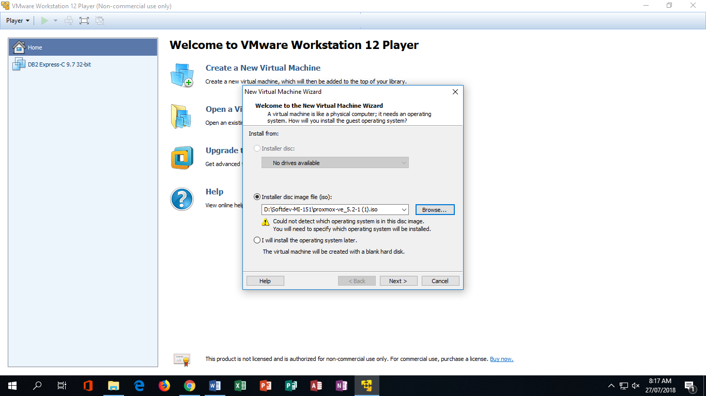

1. Choose the OS you want to run.

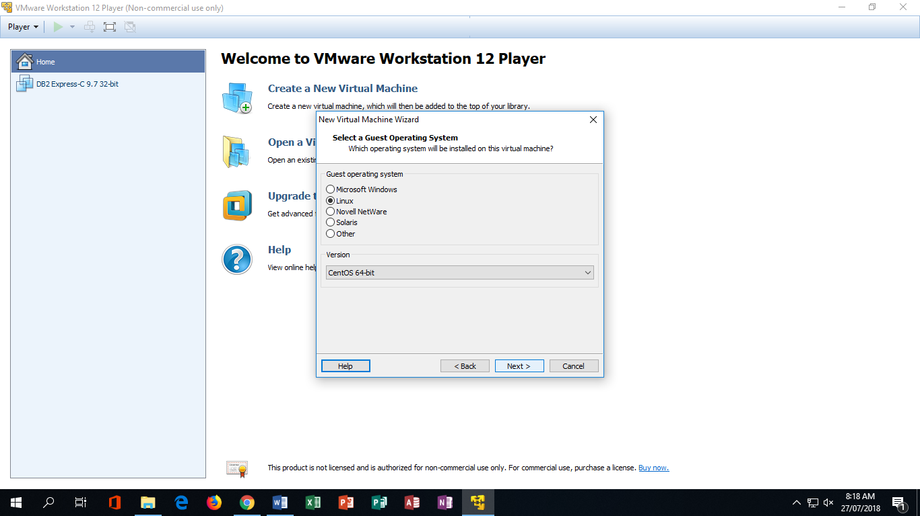

1. Choose the sizeof the ram the VM will use.

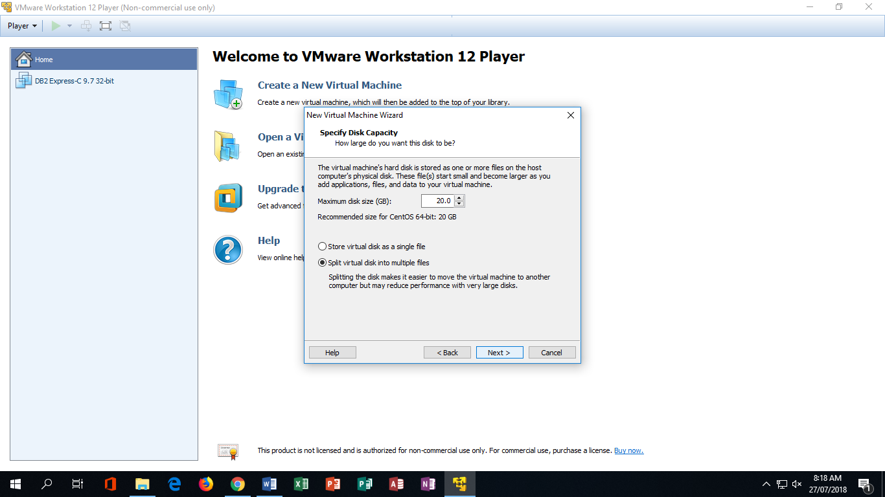

1. **Create the name of the VM**

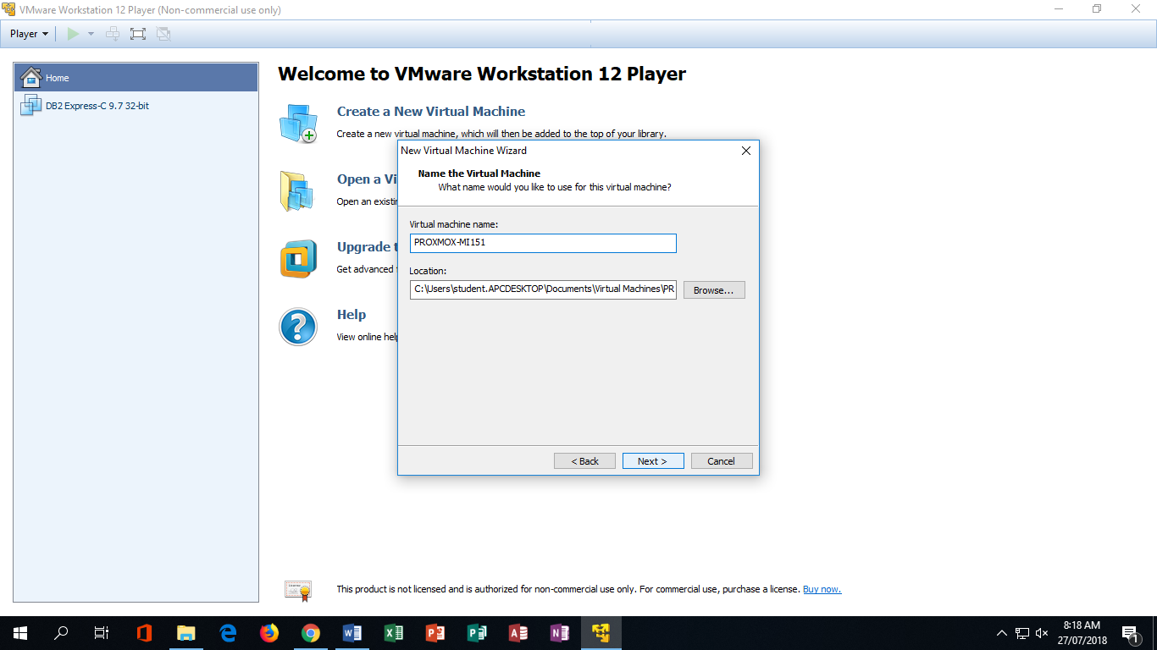

1. **Click Finish to finally start the vm.**

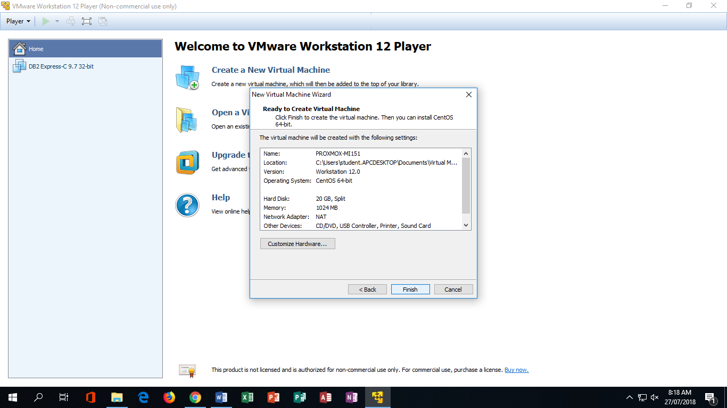

1. **Click the ‘Play Virtual machine’ to open the proxmox vm.**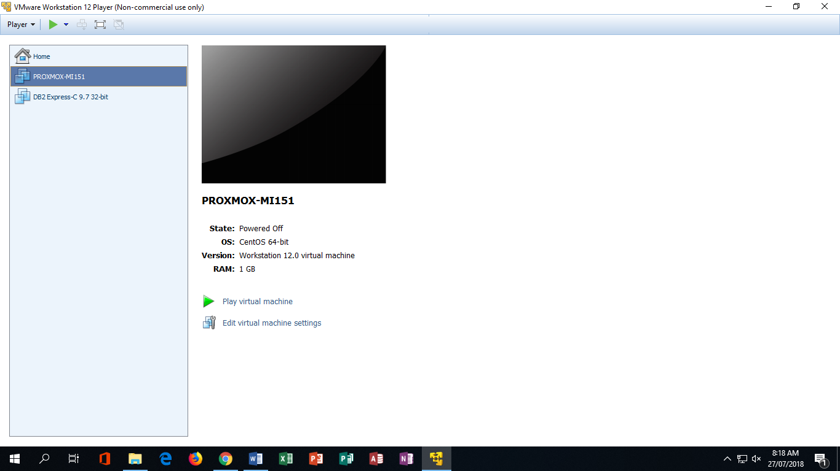

**Configuration of Proxmox**

1. Select the install Proxmox VE

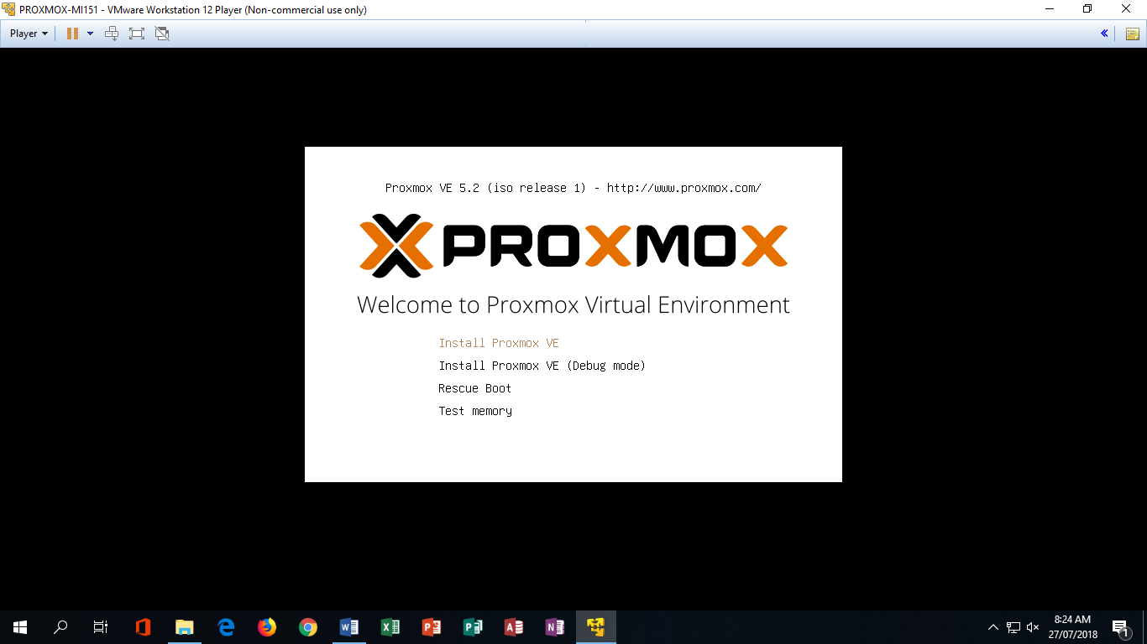

1. When error pops- out click ok then turn off the VM.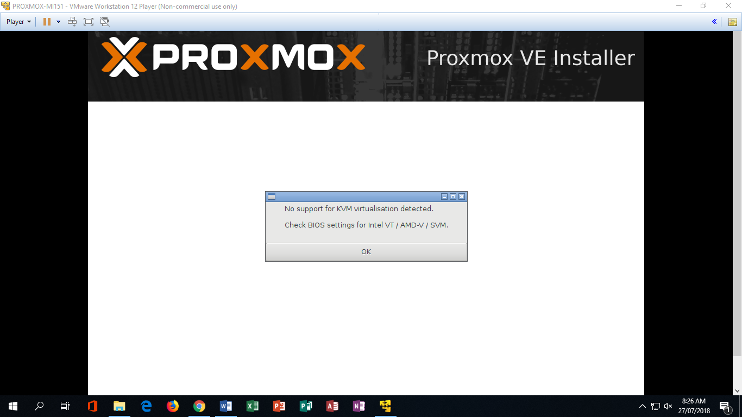
2. Go to settings.

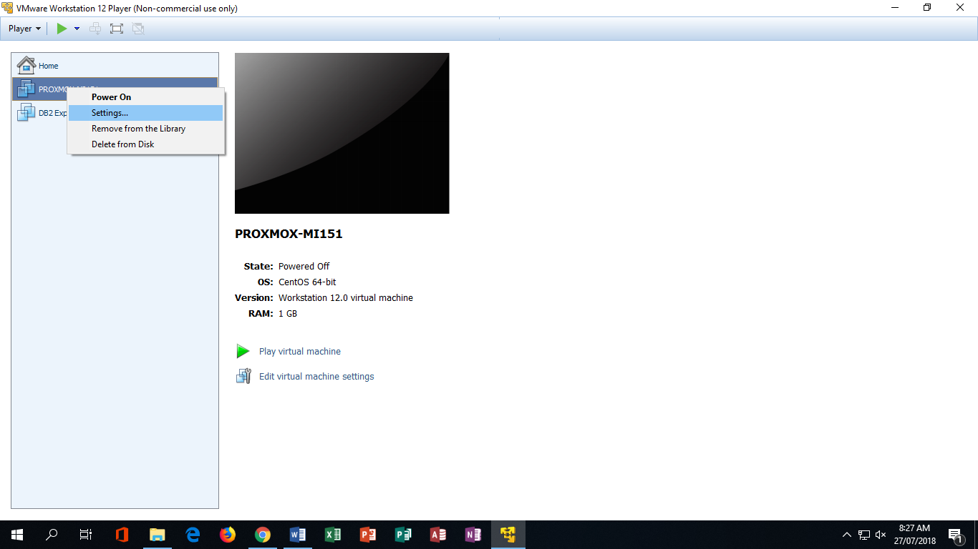

1. In the ‘Hardware tab’ click the processor.

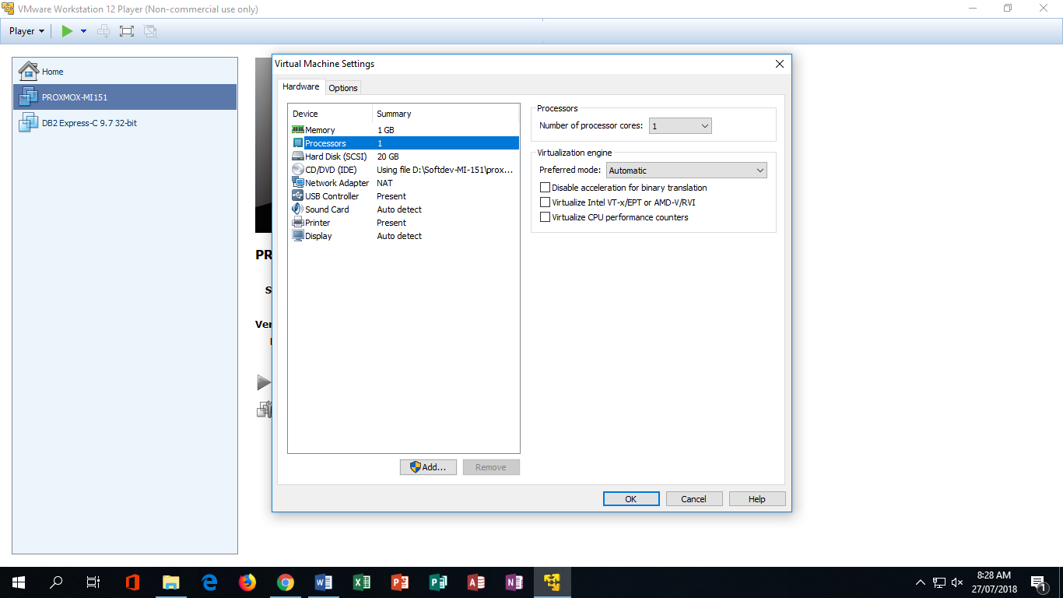

1. Check Virtualize intel VT –x/EPT or AMD-V/RVI

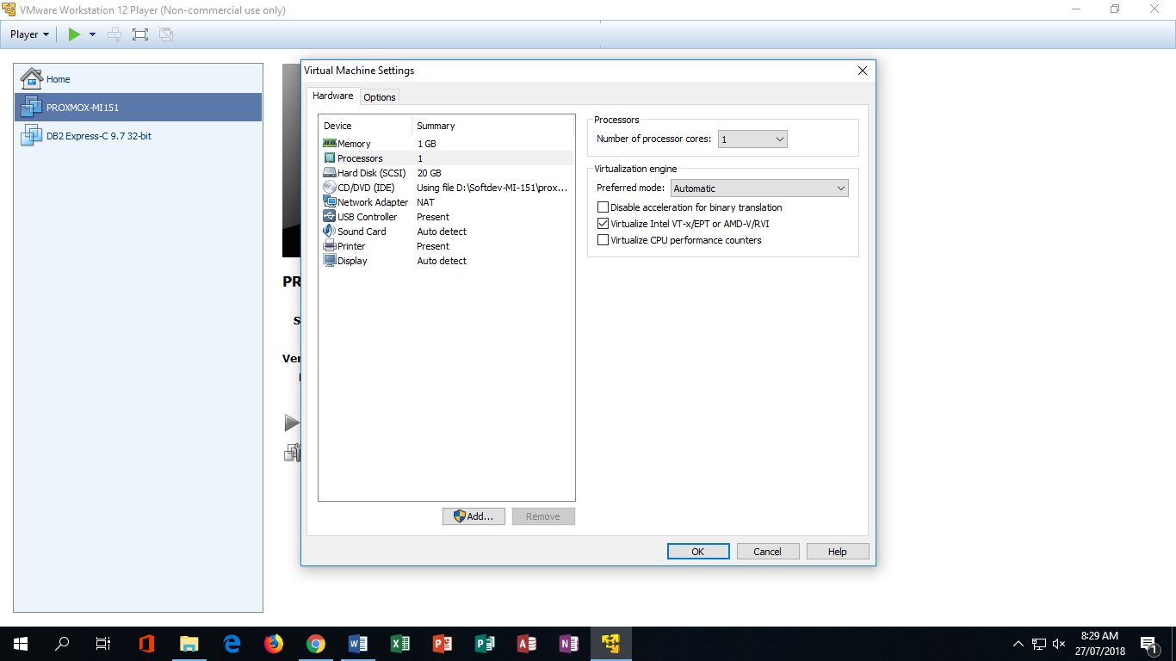

1. Open aga8in the VM and this screen will appear. Then click ‘I agree’.

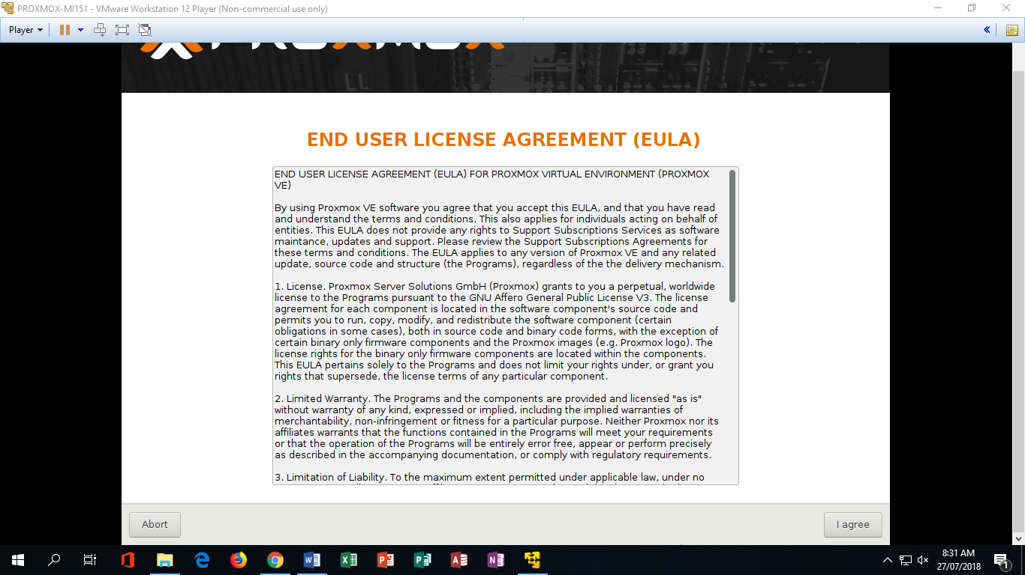

1. Click next.

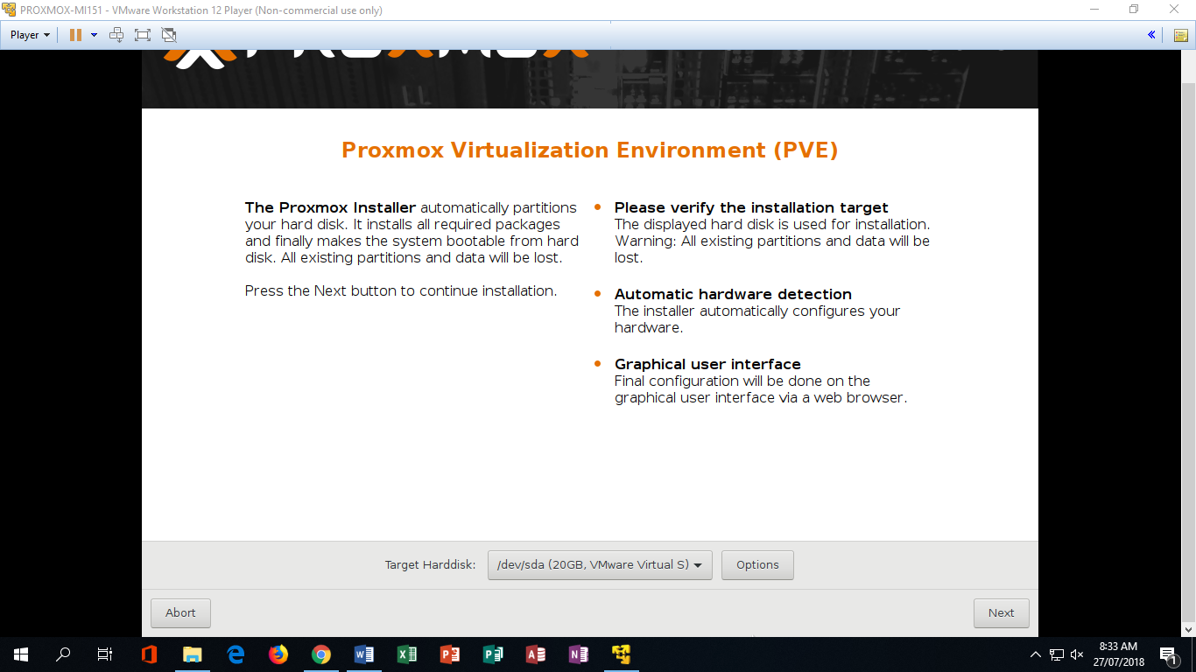

1. Select the country you are in and timezone.

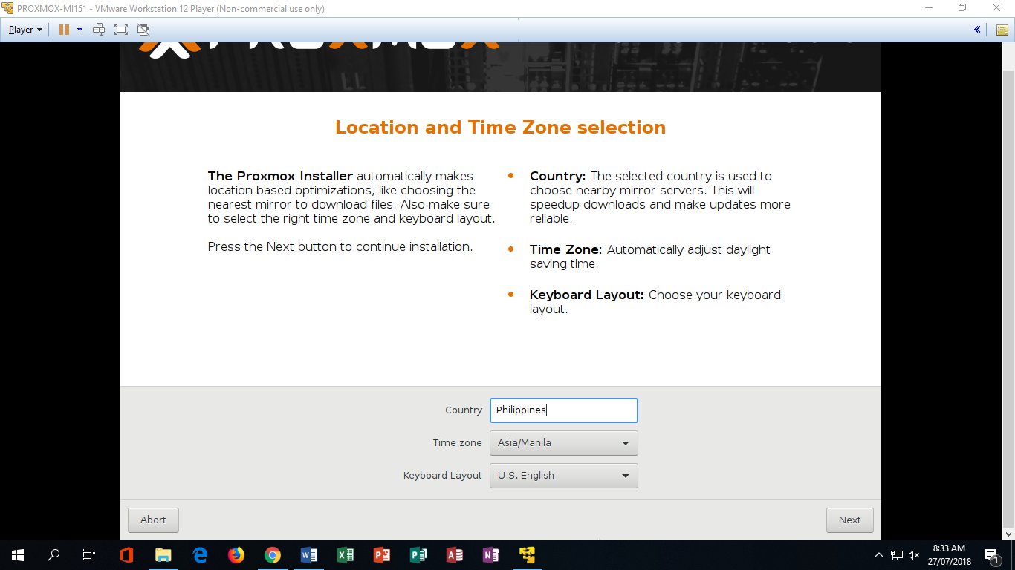

1. Input the password then the host name and ip address for the proxmox.

Hostname: sphere.localdomain

Ip address: 192.168.126.130

Netmask:255.255.255.0

Gateway: 192.168.126.2

DNS server : 192.168.126.2

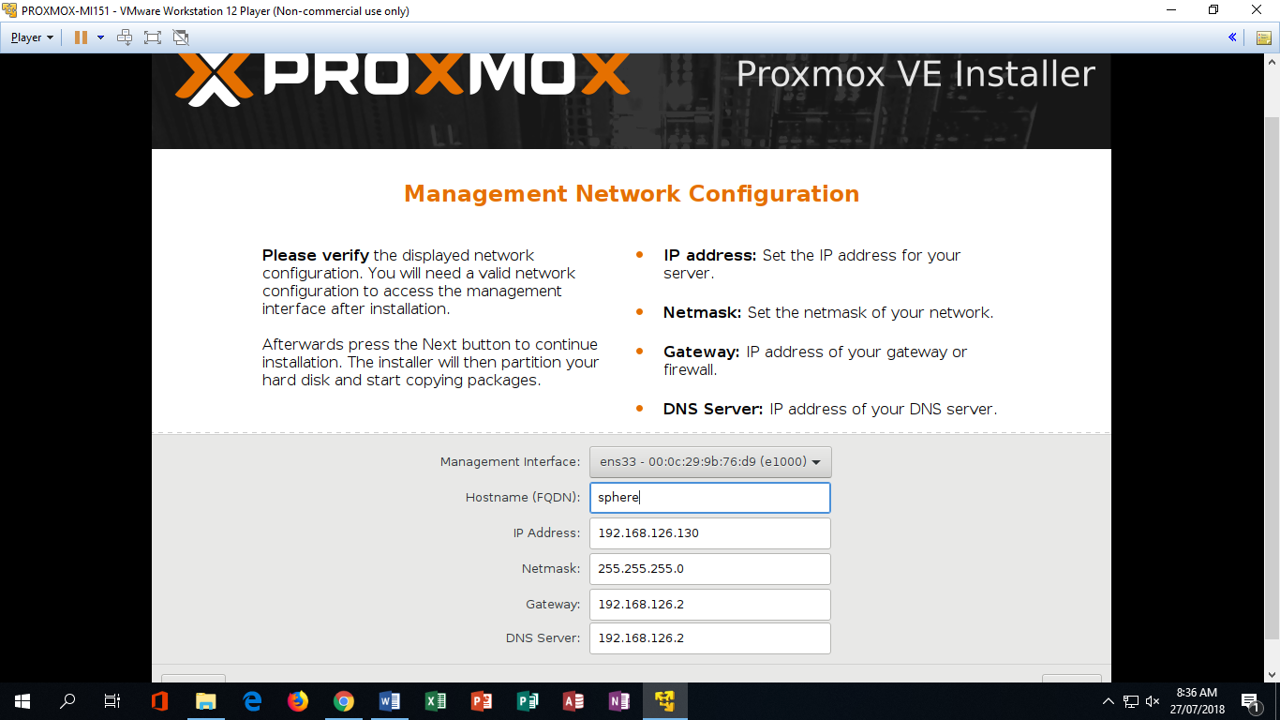

1. Wait to finish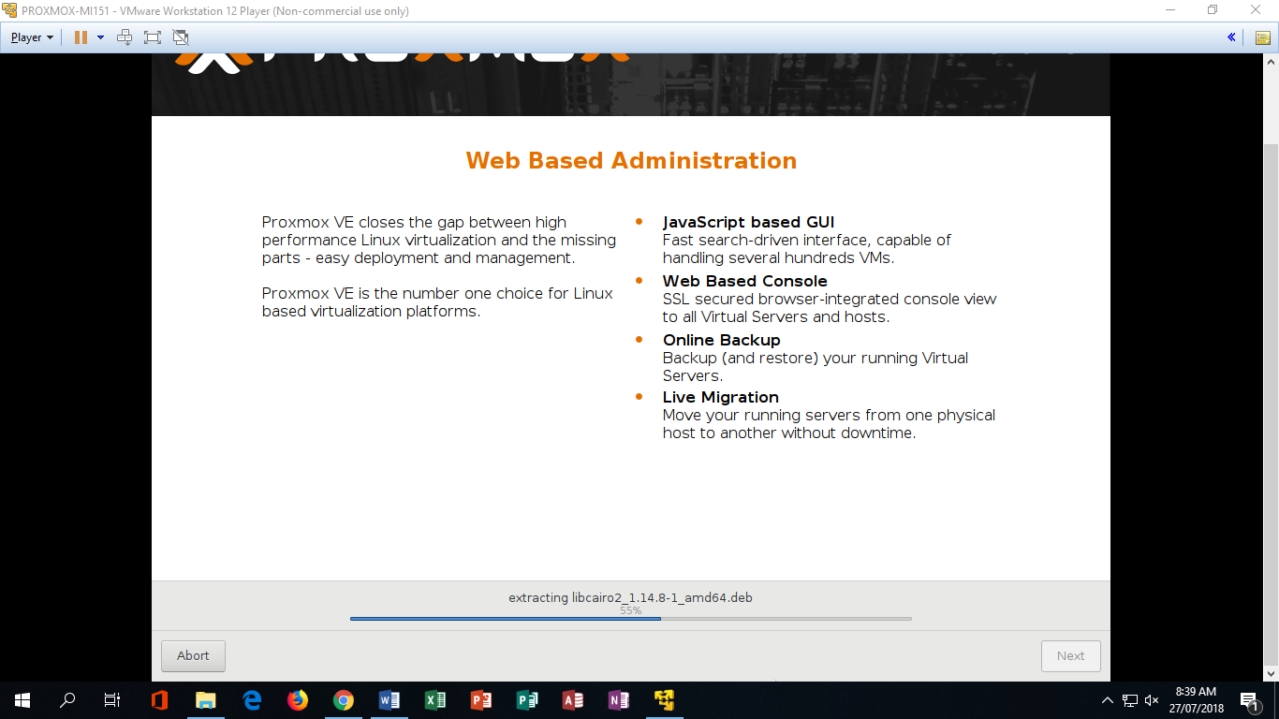
2. Click reboot.

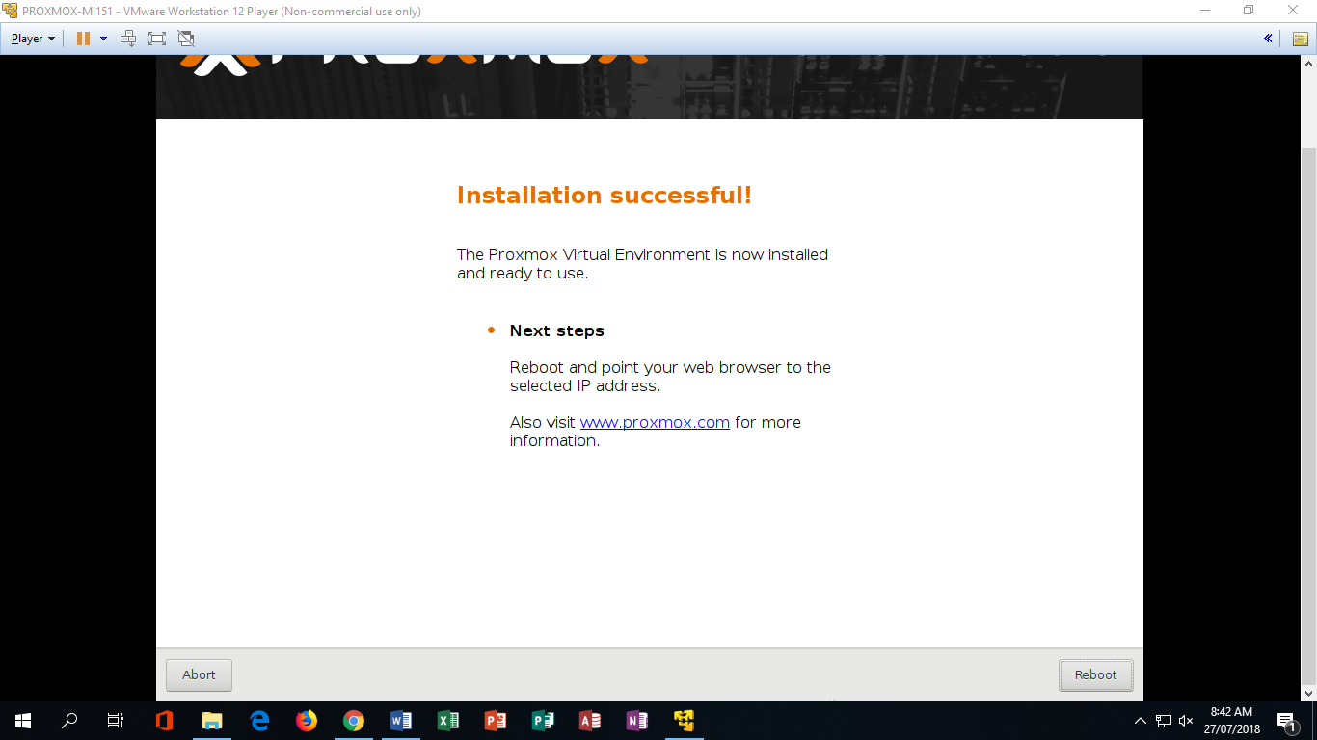

1. Input ‘root’ in the login, then input the password you entered a while ago.

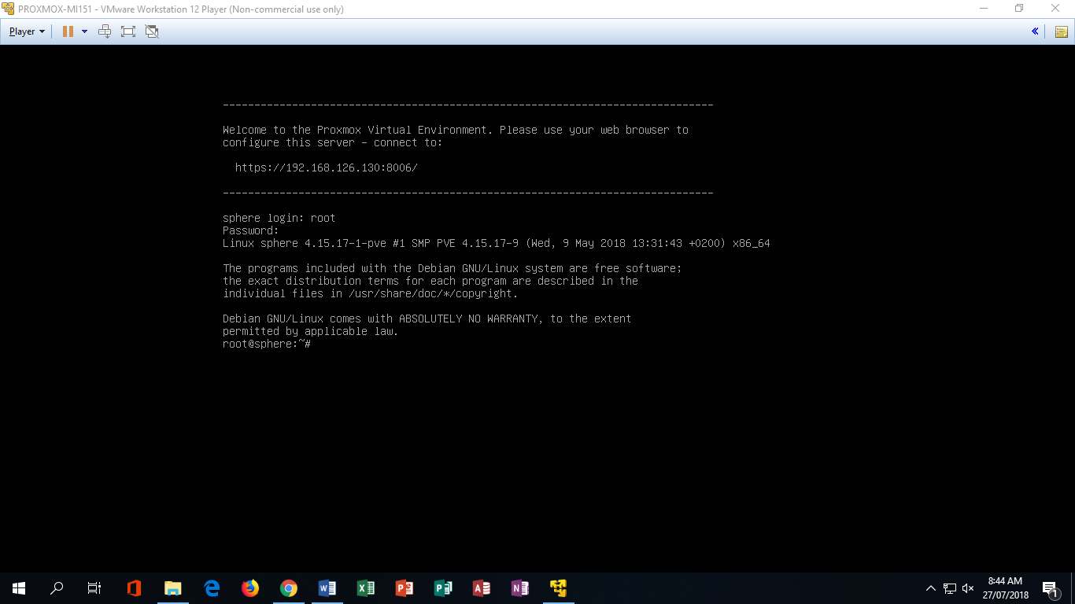

1. Input “ cat /etc/debian_version ”



1. Input “apt update” to update the proxmox vm

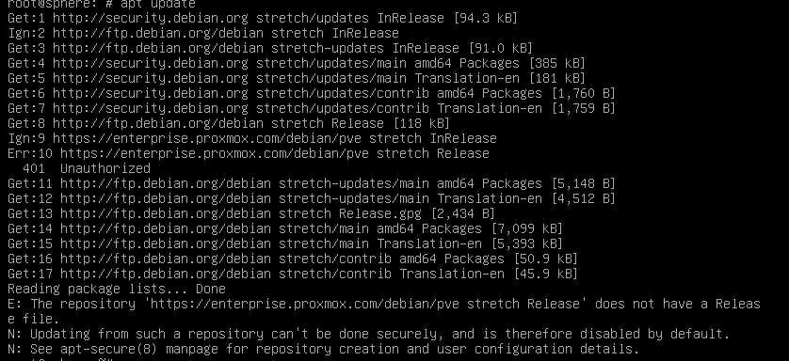

1. 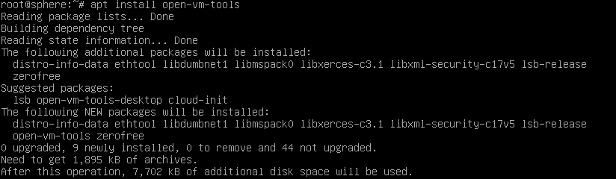Input “apt install open-vm-tools”
2. Type ‘y’ for yes

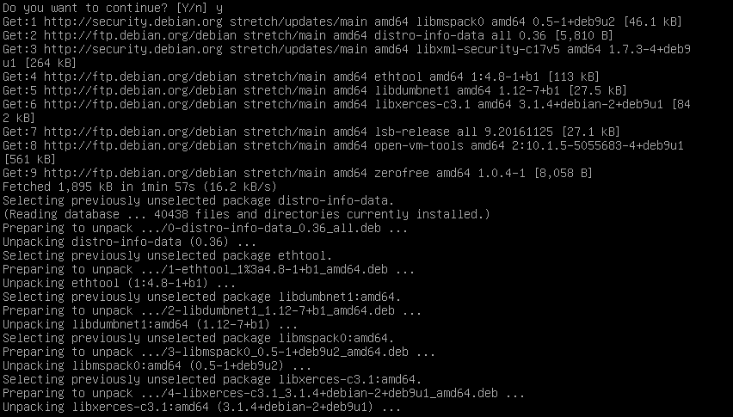

1. Type ‘reboot’ to restart the program and enter again the login: “root” and the password.
2. Type ‘systemctl status open-vm-tools.service ’ to check the status of the installed vm tools services

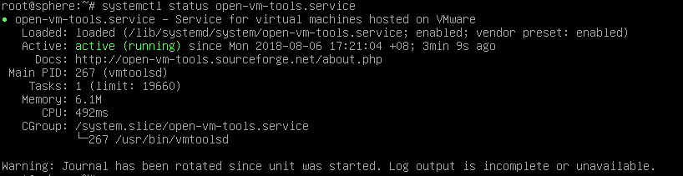

1. Type ‘exit’
2. Go to your browser and type the ip address of the proxmox which is in our example “https:192.168.162.129:8006”. Click the advance button and click the unsafe

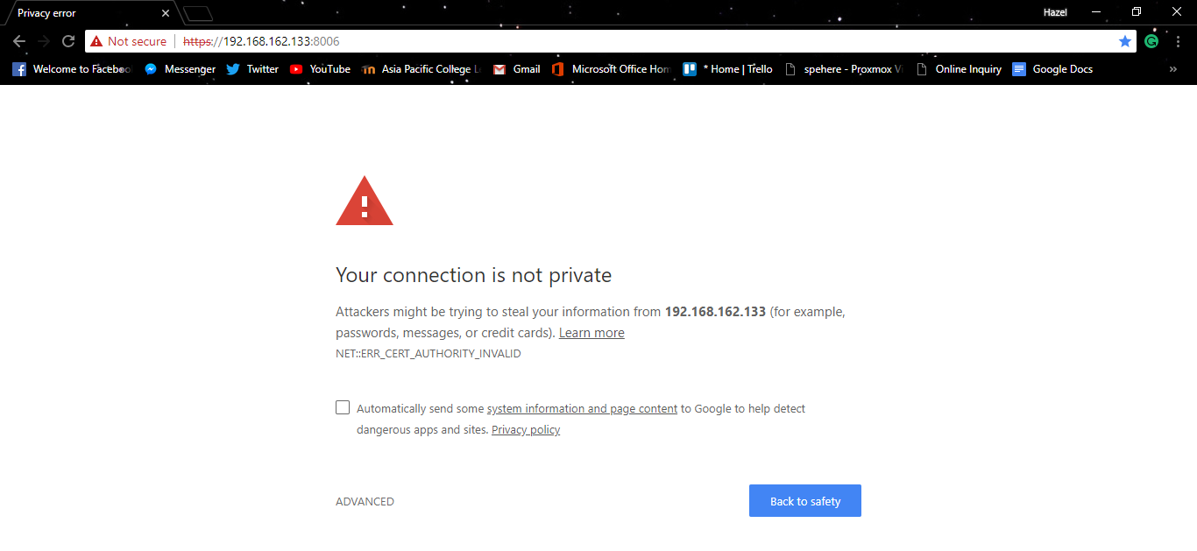

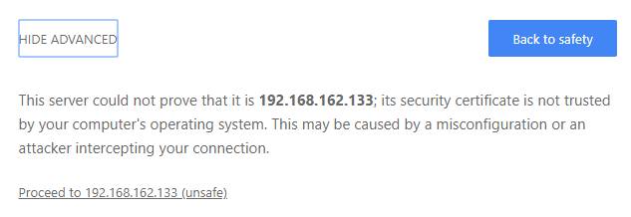

1. It will open the proxmox terminal and enter username “root” and the password you entered a while ago “softdev”

